

**System Requirements Statement (SRS) -**

1. **Health Management System**

(Serves Nation to Keep Healthy)

Doc. Ref. :

Version :

Status : Drafted

Created by : Neha Dhane

Harshala Patil

Kaushik Mandal

Sanyam Mathur

Date : 11-Jan-2020

**CONTENTS**

1. INTRODUCTION
2. FUNCTIONAL REQUIREMENTS

2.1 Account Module

2.2 Requirement Module

1. Admin
2. Patient
3. Doctor
4. Pharmacy
5. Laboratory
6. USE CASE DIAGRAM

**INTRODUCTION**

This document explains the system requirements and scope for developing smart appointment booking system that provides patients an easy way of booking a health appointment online. The scope of this document is to define the functional and non functional requirements.

E-Health Management System could be divided in four main parts - the Patient, the Doctor, the Pharmacy and the Laboratory.

**FUNCTIONAL REQUIREMENTS**

The functional requirements are divided into two major parts - (Account Module & Functionality Module) which are further sub divided as follows:

|  |  |
| --- | --- |
| **S.No.** | **DESCRIPTION** |
| **Account Module** | |
| 1 | Account Creation Process |
| 2 | Login Process |
| 3 | Forgot Password Process |
| 4 | Change Password Process |
| 5 | Update Account Process |
| **Functionality Module** | |
| **I** | **Admin** |
| 1 | Access to all the entities |
| **I** | **Patient** |
| 1 | List of Doctors Available |
| 2 | Search the Doctor |
| 3 | Book an Appointment |
| 4 | Consultation History |
| 5 | Search Pharmacy |
| 6 | Lab Reports |
| 7 | Feedback |
| **II** | **Doctor** |
| 1 | Patient Appointment List |
| 2 | Appointment Summary |
| 3 | Search Patient by Name |
| 4 | Create Prescription |
| 5 | Send Prescription to Patient & Pharmacy |
| 6 | Send Prescribed Tests to Laboratory |
| 7 | Update the Time Slots |
| **III** | **Pharmacy** |
| 1 | Patient’s Prescription |
| 2 | Medicines in Stock |
| 3 | Billing & Payment |
| **IV** | **Laboratory** |
| 1 | Prescribed Test for Patient |
| 2 | Send the Test Reports to the Patient & Doctor |
| 3 | Billing & Payment |

* **Account Module**
* **Account Creation Process**

Online Health portal compels to create the account before using it. So, this portal provides the facility to create a new account according to the user’s domain.

* **Admin Account**
* Account already created by the developer.
* **Patient Account Creation -**
* Username
* Password
* First Name
* Last Name
* Date of Birth
* Contact Number
* Address
* Past History (If any)
* Security Answer1
* Security Answer2
* **Doctor Account Creation -**
* Username
* Password
* First Name
* Last Name
* Date of Birth
* Contact Number
* Email Id
* Address
* Licence Number
* Certifications
* Experience
* Rating
* Fees
* Specialization
* Time Slots
* Security Answer1
* Security Answer2
* **Pharmacy Account Creation -**
* Username
* Password
* Company Name
* Competent Person Name
* Contact Number
* Email Id
* Address
* Drug Licence Number
* Security Answer1
* Security Answer2
* **Laboratory Account Creation -**
* Username
* Password
* Laboratory Name
* Incharge Name
* Contact Number
* Email Id
* Address
* Certified Licence Details
* Security Answer1
* Security Answer2
* **Login Process**
* On hitting to the portal, user will be targeted to the portal’s home page. This page consists of some information regarding the organization and a login tab. In order to use the services, the user has to login through their login credentials, i.e., “Username” & “Password”.
* On successful authentication of the login credentials, user will be redirected to its homepage according to its domain of specification (i.e. Patient, Doctor, Pharmacy & Laboratory).
* If authentication fails, then user will be on the same login page with a message “**Invalid Login Credentials**”.
* If Username not registered, then then user will be on the same login page with a message “**Username Not Found! Please Register…**”.
* **Forgot Password Process**

When the user lost/forgot the login password, to recover the same a method Forgot Password is provided at the login page.

* **If Security Answers Matches:**

After going on to the Forgot Password - it will ask for the registered Username. On confirming the same, it will ask for the security answers that were given at the time of registration. If it authenticated then the user will have to provide the new password which must satisfy the password constraints. The new password will be updated for that account.

* **If Security Answers doesn’t Matches:**

If the security answers doesn’t match or the user has forgot the same, then user must contact the administrator. By verifying the details and username, admin will set a temporary password for the user.

* **Change Password Process**

When the user want to change the login password, user can do the same after successfully login into portal. There will be a tab available to change the password.

To perform the same following is the process:

* First user have to provide current login password and then followed by the new password. Only when the current login password matches, then only the new password is set and updated. New Password must satisfy the password constraints.
* If the current password doesn’t matches, then user will not be able to change the login password.
* **Update Account Process**

The portal provides the registered user to update the account information.

For each domain there are different fields which can be changed/modified.

* For Patient -
* Contact Number
* Email Id
* Address
* City
* State
* Pincode
* Past History
* For Doctor-
* Contact Number
* Email Id
* Address
* City
* State
* Pincode
* Licence Number
* Certifications
* Fees
* For Laboratory-
* Contact Number
* Email Id
* Address
* City
* State
* Pincode
* Drug Licence Number
* For Laboratory-
* Contact Number
* Email Id
* Address
* City
* State
* Pincode
* Certified Licence Details
* **Functionality Module**

1. **Admin**

* **Access to All the Entities**

Admin will be able to keep a track on all the functionalities performed by the patient, doctor, pharmacy and laboratory. Admin can view the summary in the form of reports.

1. **Patient**

* **List/Search the Doctors available**

When the patient is logged in, user will be able to see the list of doctors available. Along with this, user can also view the doctors by providing the filters on the basis of area(locality), speciality and time slot.  
 User can also search the doctor by providing the name in the search field.

The list of doctors will contain the specialization and experience of the doctor. By the selecting the doctor, user can view the time slots available to get the appointment.

* **Book an Appointment**
* A patient can only book the appointment with doctor only after log in. After searching the doctor according to the need, patient can select the doctor and can view the time slots available with that doctor.
* After selecting the appropriate time slot, user can view the consultation fees and will be able to book an appointment with that doctor. The time slot selected by the user will be blocked for that doctor and now the patients will not be able to book for that slot.
* On successful booking a message will be displayed on the user’s window and the appointment will be blocked and booked with the doctor.
* **Consultation History**

Portal provides the patient to view the consultation history. This section provides the user to view the booked appointments and can check the previously prescribed prescriptions.

* **Search Pharmacy**

This section provides the user the ease to locate the pharmacy nearby. Patient can view the list of pharmacies which are registered on this portal. User can select the pharmacy and can view the offers and discount available with it.

User can also search the pharmacy by providing the filters like - area(locality) and city.

* **Lab Reports**

This section of the portal provides the access to the patient to view their lab test reports. Once the test reports are uploaded by the laboratory with the respective patient’s name, patient can view their lab test reports in this section.

* **Feedback**

After visiting the doctor, patient can provide their valuable feedback using this section. This will generate the rating for the doctor and according to that the doctor’s rating will be updated.

1. **Doctor**

* **Patient Appointment List**

When the doctor is logged in, doctor will be able to see the list of patient’s appointments. Along with this, user can also view the for which time slot patient which patient has been booked.

The list of appointment will contain the patient’s name and time slot.

* **Appointment Summary**

This section of the portal provides the doctor with the facility to view the summary of the appointments. The summary can be filtered according to the need such as - day wise and month wise summary.

* **Search Patient by Name**

Doctor can search the patient by providing the patient’s name in the search field. This will result into the details of the patient who has been treated by the same doctor. If there is no relation between the doctor and the patient then no details will be displayed.

* **Create Prescription**

As the patient visits the doctor, doctor will check for his appointment in the list of appointment and will select the same patient. After this, doctor will generate the prescription. On doing so that patient will marked as visited.

* **Send Prescription to Patient & Pharmacy**

After the prescription been generated and prescribed by the doctor, there will be a feature to the prescription to the patient as well as to the pharmacy.

* **Send Prescribed Tests to Laboratory**

While creating the prescription, doctor can also prescribe the lab tests to the patient. This will be prescribed under the tests section and will be forwarded to the Laboratory.

* **Update the Time Slots**

Using this section of the portal, the doctor will be able to change the timings for the appointment and accordingly the patients can view the time slots available for that doctor.

1. **Pharmacy**

* **Patient’s Prescription**

The pharmacist will be able to see the patient’s prescription after getting successfully logged in into the portal. Pharmacist can view the prescription details by searching the patient’s name. This will provide him with all the details of the patient.

* **Medicines in Stock**

This section will allow the pharmacist to check the stock available for the medicines.

* **Billing & Payments**

Further the user will be redirected to the billing and payment page where billed amount will be visible and the payment options are available.

1. **Laboratory**

* **Prescribed Tests for Patient**

The laboratory incharge will be able to view the prescribed tests for a patient by searching with the patient’s name. This will provide all the prescribed tests to be done for that patient.

* **Send the Test Reports to the Patient & Doctor**

After generating the test reports for the patient, it can be uploaded on the portal and the same will be shared with the patient along with that of doctor.

* **Billing & Payments**

Further the user will be redirected to the billing and payment page where billed amount will be visible and the payment options are available.

* **Use Case Diagram**
* Admin

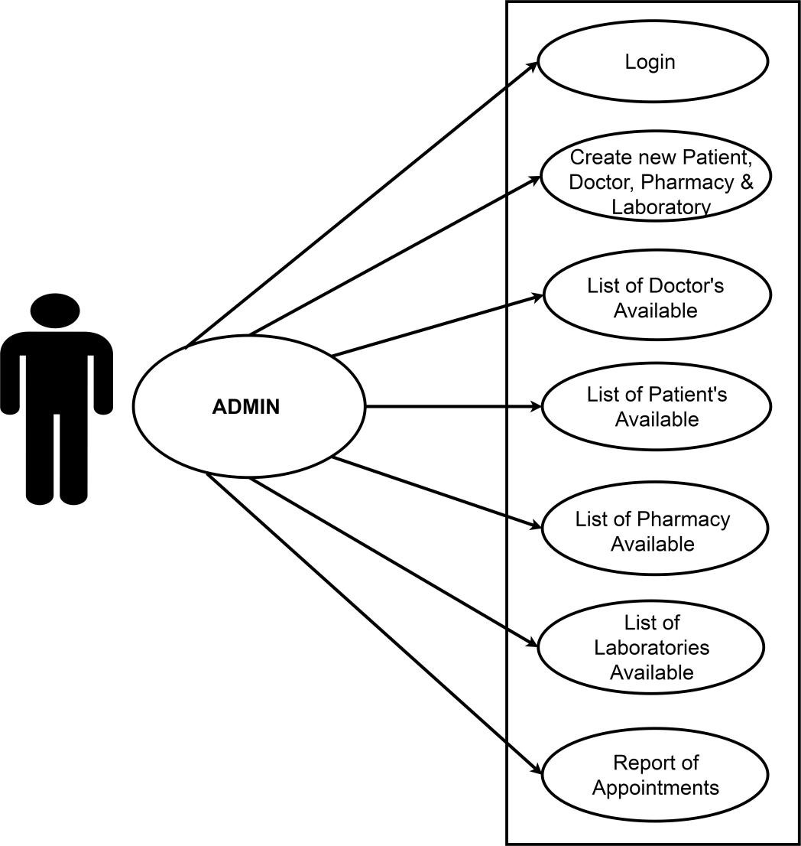

* Admin can create new account for Patient, Doctor, Pharmacy and Laboratory and can manage their account for any updates.
* Admin can view the list of users available for the different domains.
* Admin can view the report of appointments.
* Patient

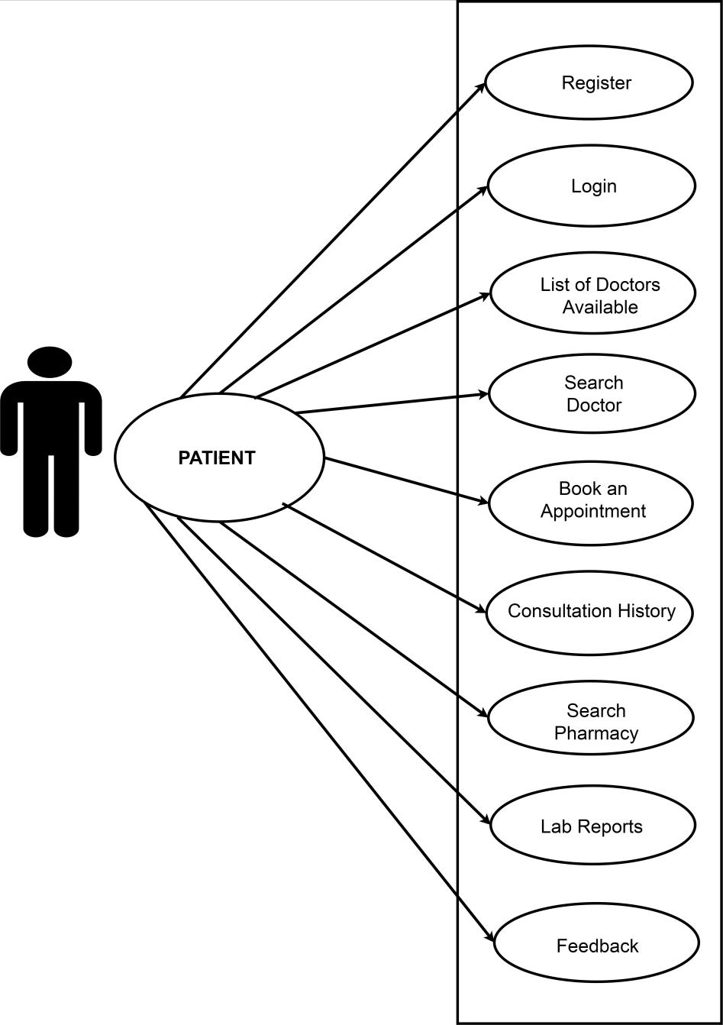

* Patient can register onto the portal and after login can access the services
* Patient can view the doctors available.
* They can search the doctor by name.
* Patient can book an appointment for any doctor.
* Patient can view their consultation history.
* Patient can search the pharmacy.
* Patient can view their lab reports.
* They can provide their feedback.
* Doctor

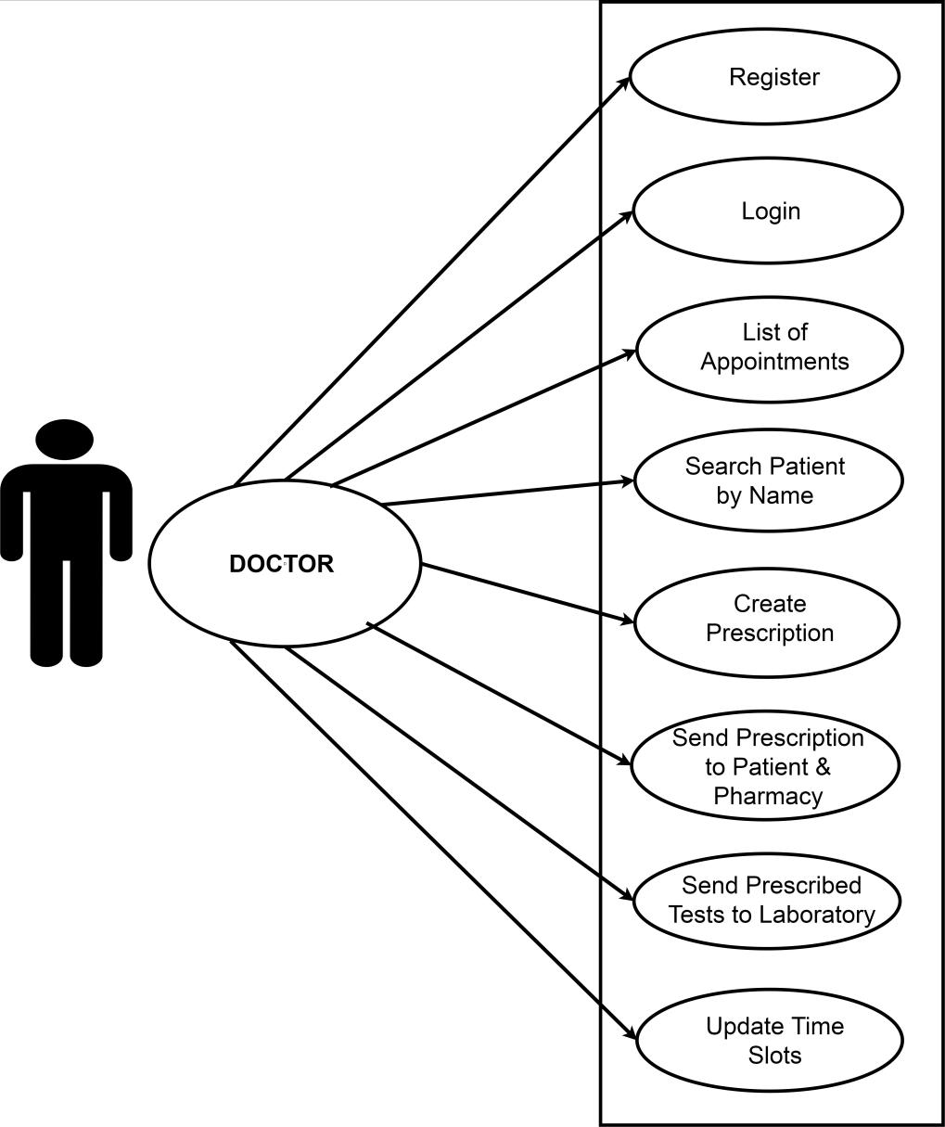

* Doctor can register onto the portal and after login can access the services
* Doctor can view the list of appointments.
* Doctor can create the prescription when the patient visits to him.
* They can send the prescription to the patient as well as to the pharmacy.
* Doctor can send the list of prescribed tests to the laboratory.
* Doctor can update the time slots if any change has to be made.
* Pharmacy

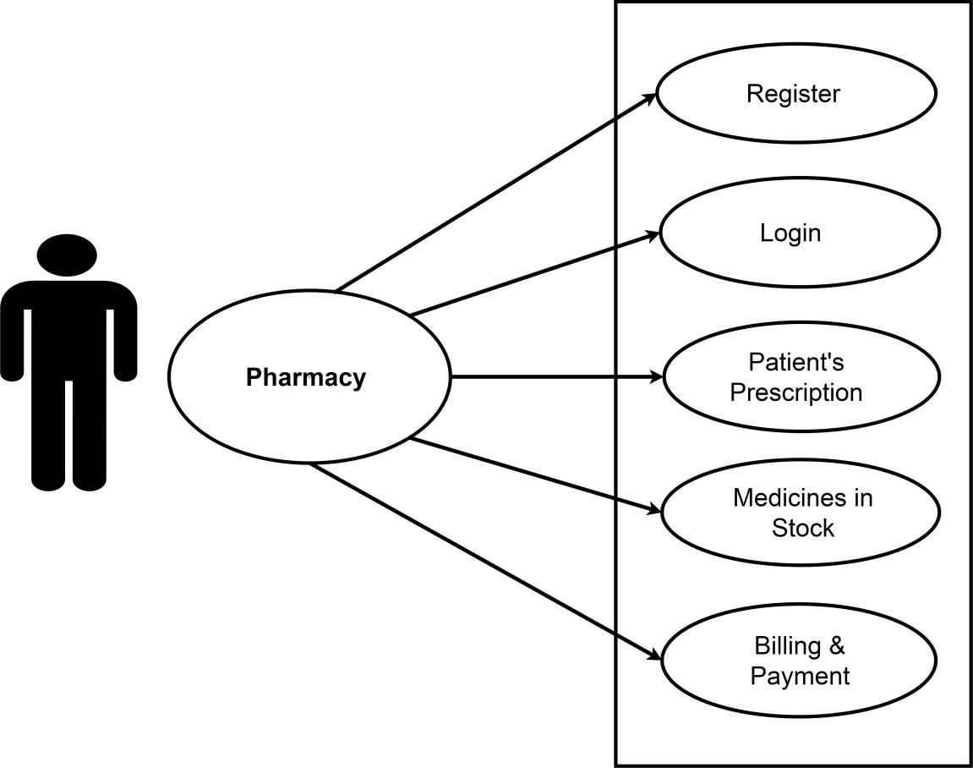

* Pharmacy can register onto the portal and after login can access the services
* Pharmacy can view the patient’s prescription.
* They can view the medicines in stock.
* Pharmacy can handle the billing & payment with this functionality.
* Laboratory

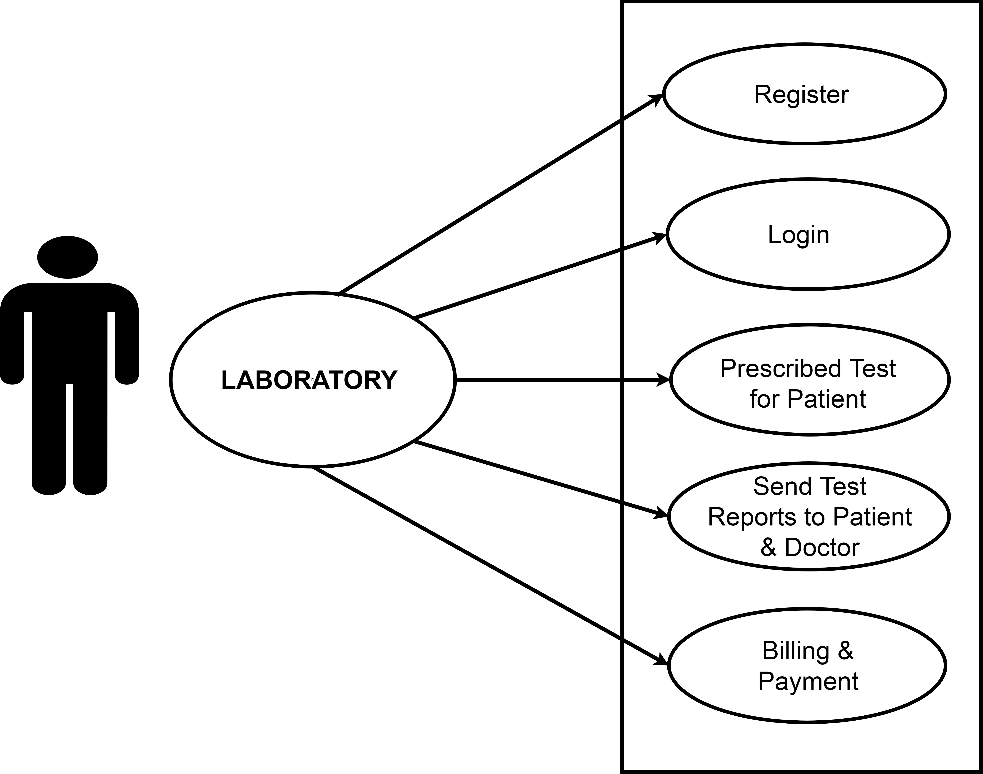

* Laboratory can register onto the portal and after login can access the services
* Laboratory can view prescribed test’s for the patient.
* They can send the test reports to the patient and to the doctor.
* Laboratory can handle the billing & payment with this functionality.